1. Consider the following consulting project:

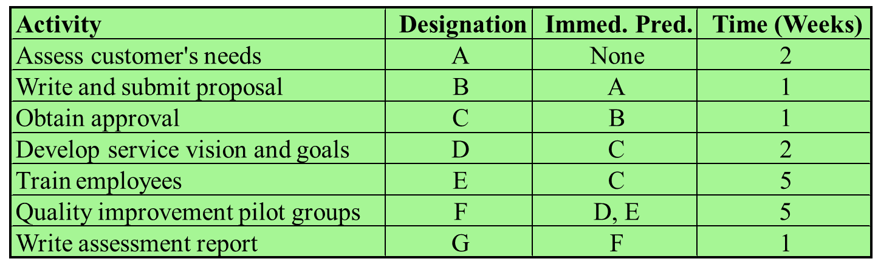

Develop a critical path diagram and determine the duration of the critical path and slack times for all activities.

1. Draw the network
2. Determine early starts and early finish times of each activity
3. Determine late starts and late finish times of each activity
4. Determine the slack of each activity
5. Determine the critical path
6. Consider the following project:



1. What is the probability of finishing this project in less than 53 weeks?
2. What is the probability that the project duration will exceed 56 weeks?